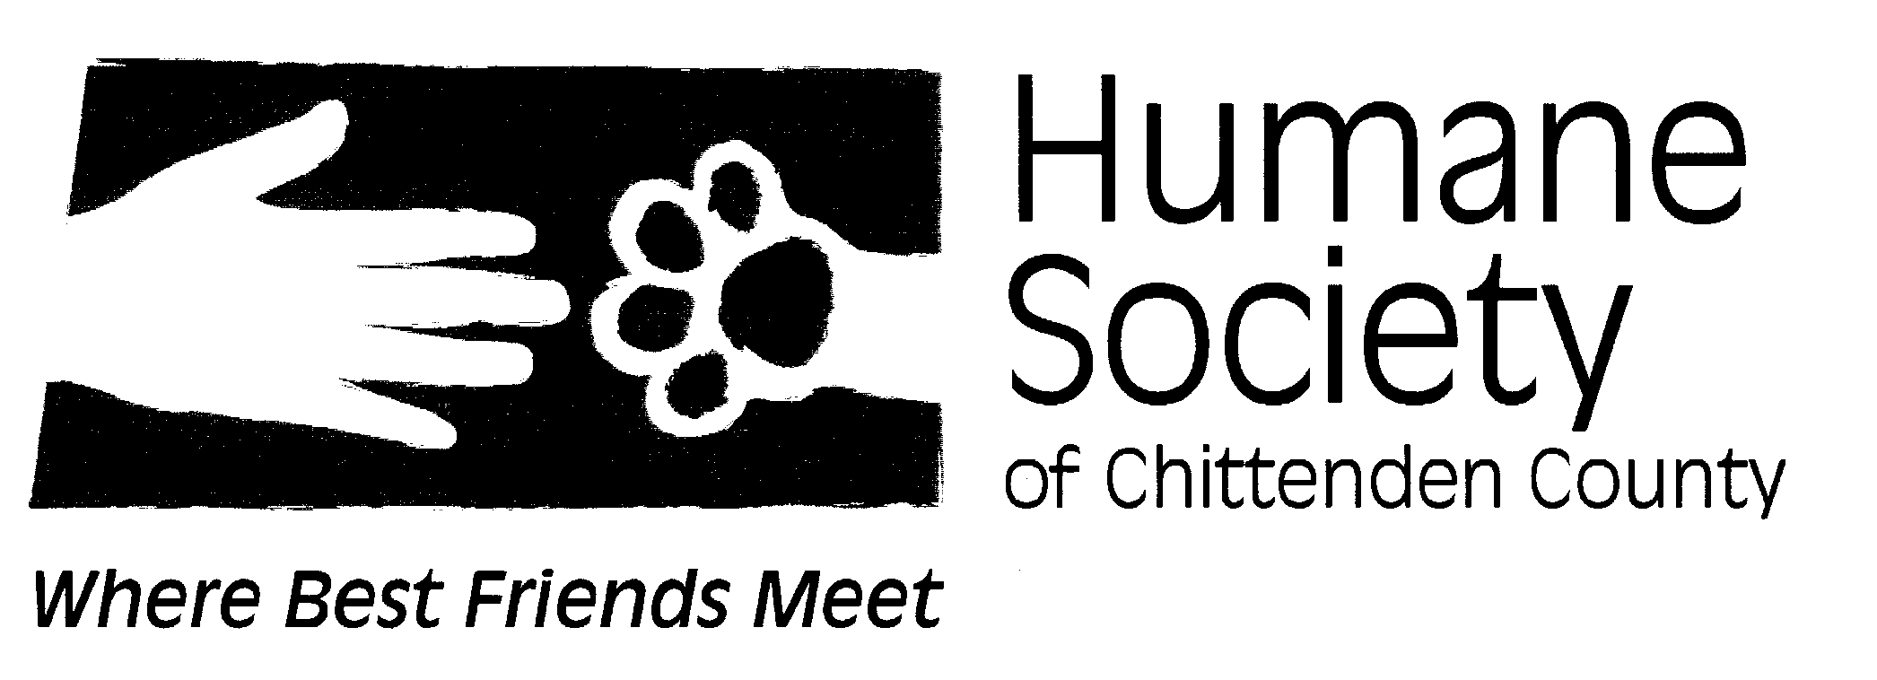
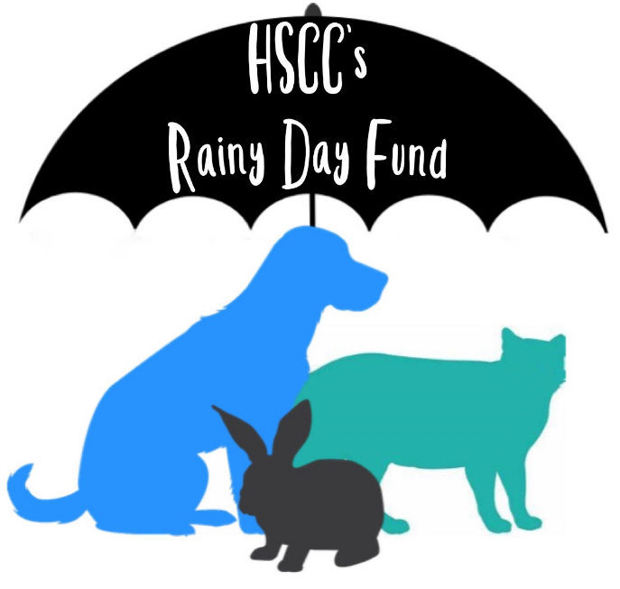

Rainy Day Fund
Humane Society of Chittenden County’s Rainy Day Fund is designed to help Chittenden and Grand Isle County residents who are struggling to provide adequate care for their companion animals. It is our goal to keep pets in their homes whenever possible.
The HSCC Rainy Day Fund includes:
Emergency Grant for Surgical Procedures (not to exceed $1,500 per family per year, based on first time receiving service, contingent on program funding and request for assistance)
To qualify for the HSCC Rainy Day Fund, one must:
- Provide proof of Chittenden or Grand Isle County residency

- Provide proof of limited or fixed income (SSI / Disability / pay stub)

- Agree to work with HSCC to have family pet receiving assistance to be spayed or neutered

- Agree to inform HSCC if financial status changes such that assistance is no longer needed

- We are unable to provide repayment for veterinary expenses already incurred by applicant.

- The Rainy Day Fund is intended for future veterinary care/procedures. As such, we are unable to reimburse for veterinary procedures that have already been completed.

Please feel free to call (802) 862-0135 x19 with any questions or concerns you may have.
To apply for Rainy Day Fund assistance, please complete and submit the form below. You will also need to supply us with:
- A signed application
- Proof of Chittenden County or Grand Isle County residency (copy of driver’s license, passport, item of mail, etc.)
- Proof of low income (Social Security / Disability benefits form / pay stub)
- Current estimate from your vet detailing medical needs and total estimate of cost for care/procedure
- Previous veterinary records for pet in need of care/procedure (if applicable)

Personal Information
- Applicant Name: ____________________________________________________
- Date of Birth: _____________________

- Home Phone: _____________________
- Cell Phone: _____________________

- Work Phone: _____________________

- Email: _____________________

- Address: ______________________________________________________

- Combined monthly family income before taxes:_______________________________

  - Source of income (e.g Employed, Unemployment, Disability, SSI):____________
  - Number of members in household:__________
- Reason(s) you are applying for pet care assistance:

Pet Information
- Pet Type: __ Cat __ Dog __Other: _________________

- Name of Pet: ____________________
- Age of Pet:________________

- Gender of Pet: __Male __Female
- Fixed? __ Yes __ No

Terms
With my signature, I certify that the information I have given is true. I understand Rainy Day Fund assistance is being provided to my pets, based on the information above. I understand in order to receive pet care assistance the following conditions must be met:
  - I am a resident of Chittenden or Grand Isle County, Vermont

  - I will work with HSCC to have my pet receiving assistance be spayed or neutered

  - By accepting these grant funds, recipient agrees to allow HSCC to share their story with their donors, for the purpose of sustaining the fund (all names and personal information will always be kept confidential).

  - I have supplied HSCC with a copy of my proof of income along with my Rainy Day application. __ Yes __No
(*We can only move forward with reviewing your application after we have received this information)

- I agree to the program's terms as enumerated above. __ Yes __No

Signature:___________________________________________ Date:____________

Print Name:__________________________________________

